

Getting Going

Registration

Each time Multi-SWAC is entered the registration is checked.

On purchase a Rego ID along with an associated e-mail address will be e-mailed to the registered e-mail address.

When registering Multi-SWAC you will need to be connected to the internet. This connects with the registration server to confirm the Rego ID and the associated e-mail address. If the registration information is correct, Multi-SWAC will be unlocked.

Getting Started Tutorial (Years and Items)
Object: To show how to do a basic initial setup of Multi-SWAC, adding items, editing items and adding a year.

Open Multi-SWAC
Select New Zealand as country - this sets up the default TAX (GST) for the tutorial. Use New Zealand to cross check numbers shown below.
Upon opening Multi-SWAC the User Interface is displayed.
- Save the file as "Tutorial Using Multi-SWAC”
- Right click of Year tab and select edit year - enter the year e.g. 2008
- Right click on Company tab and select edit company - enter "Wholesale"

The User Interface should now show:
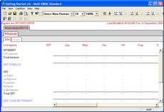

Select Cashflow>Display Options
- Formatting - untick cents.

Select Cashflow>Tax Setup
- Leave as is - but rate can be altered if required.

Add the following items to the forecast (Item>Add Item)
Type | Item Name
Income | Sales
Direct Costs | Purchases
Expenses | Bank Fees
Expenses | General
Expenses | Rent
Investment | Interest Bearing
Loan | BNZ

The User Interface should now show as below:
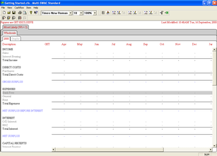

Edit each item in turn (Item>Edit Item). Set:
Item | Tax | Amount
Sales | S | Enter 1,000 for each month - use the copy down button - Next Item button
Purchases | S | Set Percentage to 35% - copy down - Next Item button
Bank Fees | E | Enter 10 for each month - Next Item button
General | S | Enter 25 for each month - Next Item button
Rent | S | Enter 550 for each month
Bank Account |  | Set opening balance to 2,300 - Set OD Limit ($) to 10,000 - Set Interest Rate (%) to 12% for all months- Next Item button
Interest Bearing |  | Opening Balance 0 - Advance ($) 2,000 in May - Interest Rate (%) 8.7 for all months - Next Item button
BNZ |  | Opening Balance 0 - Advance ($) 5,000 July - Interest Rate (%) 9.8 for all months - Payment 100 for August onwards
 |  | Save & Close

The User Interface should now show as below:
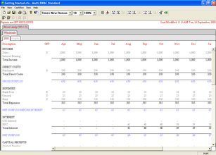

Next add another year (Cashflow>Add Year)
Copy From | Select Prior Year
Number of Months | 12
A complete copy of the data from 2008 will be copied into the 2009 tab. Balances from previous year for bank, investment, loans plus tax will be bought forward.
Edit 2009 year:
Interest Bearing Investment | Edit May to 0 - ensure interest rate the same for all months at 8.69
BNZ Loan | Edit July Advance to 0 - set all Interest Rate (%) to 8.9 - set all Payments ($) to 100
Purchases | Change % to 30 from June onwards
Sales | Increase Sales to 1200 per month from August

At the end of 2009 the following balances should be displayed
Total Sales | 13,600
Total Purchases | 4,180
Total Expenses | 7,020
Total Interest | 407
Total Capital Payments | 793
Total GST | 48
Bank Account Balance | 6,546
Total Interest Bearing | 2,344
Bank Account Balance | 3,720

Multi-SWAC has been setup for 2 years with some basic data

Getting Started Tutorial (Company)
Object: To show the operation companies in Multi-SWAC.
Within Multi-SWAC Companies can be either:
- Companies
- Cost Centers
Right click on the company tab Wholesale
Select Add Company (Cashflow>Add Company)
Set
- Copy from - Blank
- Company Name - Retail

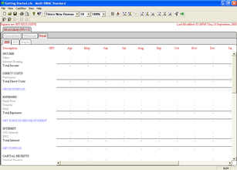
Note another two company tabs have been added:
- Retail
- Consolidated
Also note that there is no data in the years

Add another Company
Set
- Copy from - Wholesale
- Company Name - Other
Note a third company has been added with data that is the same as for Wholesale
- Select the Consolidated company tab and the 2008 tab
- The sales for April = 2000 - being sum of Wholesale 1000, Retail 0, and Other 1000
- Select Retail tab and add sales of 1000 for March
- Select Consolidated tab - total now 3000

Move tabs around
- Hold left mouse button down over the Other company tab and drag to new position and release button - tab is now in its new position
- Note - the Consolidated tab cannot be moved

Getting Started Tutorial (Scenario)
Object: To show the operation scenarios in Multi-SWAC.
- Right click on the Most Likely tab
- Select add Scenario
  - Copy from - Blank
  - Scenario Name - Best
  - Weighting - 2

Note another two scenario tabs have been added:
- Best
- Consolidated
Also note that there is no data for all combinations of companies and years for the Best scenario.
For the following combination of
- Consolidated scenario
- Consolidated company
- 2008
The amount should be for April - 2143
For the Best scenario and for each company and 2008 edit the amount to 1000 for April
For the following combination of
- Consolidated scenario
- Consolidated company
- 2008
The amount should be for April - 3000

Move tabs around
- Hold left mouse button down over the Best scenario tab and drag to new position and release button - tab is now in its new position
- Note - the Consolidated tab cannot be moved

Getting Started Tutorial - Graph
Object: How to use graph function.
Prerequisites: Complete the tutorials above.

Select the Graphs tab
The following should be displayed:
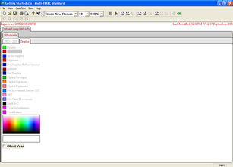
Click on Income in the legend. The lettering should change to red and the graph displayed:

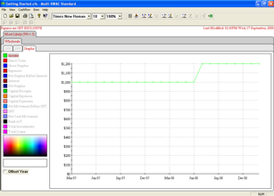
The body of the graph now shows the line graph of the sales.
Move the mouse over the colour selection and see the box below change to the colour currently under the mouse.
Click the mouse button
Note the legend of the Income and the colour of the line graph alter to the new selected colour.
Click the Offset Year - note the year increases by one on the x axis.

