

Getting Going

Registration

Each time Multi-SWAC is entered the registration is checked.

On purchase a Rego ID along with an associated e-mail address will be e-mailed to the registered e-mail address.

When registering Multi-SWAC you will need to be connected to the internet. This connects with the registration server to confirm the Rego ID and the associated e-mail address. If the registration information is correct, Multi-SWAC will be unlocked.

Getting Started Tutorial (Years and Items)
Object: To show how to do a basic initial setup of Multi-SWAC, adding items, editing items and adding a year.

Open Multi-SWAC
Select Advanced
Select New Zealand as country - this sets up the default TAX (GST) for the tutorial. Use New Zealand to cross check numbers shown below.
Upon opening Multi-SWAC the User Interface is displayed.
- Save the file as "Tutorial Using Multi-SWAC"
- Right click of Year tab and select edit year - enter the year e.g. 2008
- Right click on Company tab and select edit company - enter "Wholesale"
- Right click on Company tab and select edit company - enter "Wholesale" and leave currency weighting as 1

The User Interface should now show:
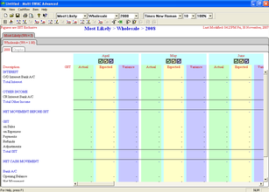

Select Cashflow>Display Options
- Actual column select Unselect All
- Variances column select Unselect All
- Number Formatting - untick cents.
The User Interface should now show as below:
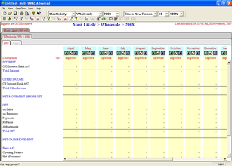
Select Cashflow Tax Setup
- Leave as is - but rate can be altered if required.

Add the following items to the forecast (Item>Add Item)
Type | Item Name
Income | Sales
Direct Costs | Purchases
Expenses | Bank Fees
Expenses | General
Expenses | Rent
Other Income | Dividend Received
Investment | Interest Bearing
Loan | BNZ

The User Interface should now show as below:
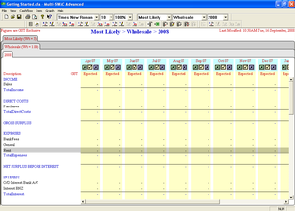
Edit each item in turn (Item>Edit Item). Set:
Item | Tax Rate | Amount
Sales | S | Enter 1,000 for each month - use the copy down button - Next Item button
Purchases | S | Set Percentage to 35% - copy down - Next Item button
Bank Fees | E | Enter 10 for each month - Next Item button
General | S | Enter 25 for each month - Next Item button
Rent | S | Enter 550 for each month - Next Item button
Dividend Received | E | Enter 400 for June only
Bank Account |  | Set opening balance to 2,300 - Select Hide CR Interest - Set Dr Interest Rate (%) to 12% for all months - Set OD Limit ($) to 10,000 - Next Item button
Interest Bearing |  | Opening Balance 0 - Advance ($) 2,000 in May - Interest Rate (%) 8.7 for all months - Next Item button
BNZ |  | Opening Balance 0 - Advance ($) 5,000 July - Interest Rate (%) 9.8 for all months - Payment 100 for August onwards
 |  | Save & Close

The User Interface should now show as below:
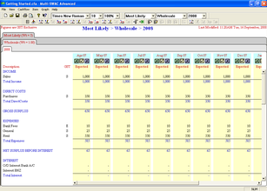

Next add another year (Cashflow>Add Year)
Copy From | Prior Year - Expected to Expected
Number of Months | 12
A complete copy of the data from 2008 will be copied into the 2009 tab. Balances from previous year for bank, investment, loans plus tax will be bought forward.
Edit 2009 year:
Interest Bearing Investment | Edit May to 0 - ensure interest rate the same for all months at 8.69
BNZ Loan | Edit July Advance to 0 - set all Interest Rate (%) to 8.9 - set all Payments ($) to 100
Purchases | Change % to 30 from June onwards
Sales | Increase Sales to 1200 per month from August

At the end of 2009 the following balances should be displayed
Total Sales | 13,600
Total Purchases | 4,180
Total Expenses | 7,020
Total Interest | 407
Total Other Income | 400
Total Capital Payments | 793
Total GST | 48
Bank Account Balance | 7,346
Total Interest Bearing | 2,344
Bank Account Balance | 3,720

Multi-SWAC has been setup for 2 years with some basic data
Setup some actual data
Turn on actual columns for April to June
Enter the following data in sales actuals (Cashflow>Edit Item)
- April 07 - 500
- May 07 - 600
- June 07 - 700
- April 08 - 900
- May 08 - 1000
- June 08 - 1100
Turn on the variance column for April to June
The 2008 screen should look like:
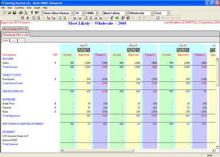

Getting Started Tutorial (Company)
Object: To show the operation companies in Multi-SWAC.
Within Multi-SWAC Companies can be either:
- Companies
- Cost Centers
Right click on the company tab Wholesale
Select Add Company (Cashflow>Add Company)
Set
- Copy from - Blank
- Company Name - Retail
- Currency Weighting - 1.25

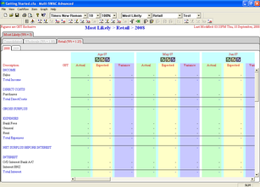
Note another two company tabs have been added:
- Retail
- Consolidated
Also note that there is no data in the years

Add another Company
Set
- Copy from - Wholesale
- Company Name - Other
- Currency Weighting - 1
Note a third company has been added with data that is the same as for Wholesale
- Select the Consolidated company tab and the 2008 tab
- The sales for April = 2000 - being sum of Wholesale 1000, Retail 0, and Other 1000
- Select Retail tab and add expected sales of 1000 for March
- Select Consolidated tab - total now 3250 - being previous total plus Retail 1000 * 1.25

Move tabs around
- Hold left mouse button down over the Other company tab and drag to new position and release button - tab is now in its new position
- Note - the Consolidated tab cannot be moved

Hiding company tabs (Cashflow>Hide Company)
A company tab can be hidden along with all its associated data. When hidden the data is still added into the consolidated tab. If the data is not to be added in alter the currency weighting to 0 (Cashflow>Edit Company)
All company tabs including the Consolidated tab are able to be hidden
- Right click on a company tab and select Hide Company
Review the effect on the Consolidated company tab

Unhide the company (Cashflow>Unhide Company)

Getting Started Tutorial (Scenario)
Object: To show the operation scenarios in Multi-SWAC.
- Right click on the Most Likely tab
- Select add Scenario
  - Copy from - Blank
  - Scenario Name - Best
  - Weighting - 2

Note another two scenario tabs have been added:
- Best
- Consolidated
Also note that there is no data for all combinations of companies and years for the Best scenario.
For the following combination of
- Consolidated scenario
- Consolidated company
- 2008
The amount should be for April - 2143
For the Best scenario and for each company and 2008 edit the expected amount to 1000 for April
For the following combination of
- Consolidated scenario
- Consolidated company
- 2008
The amount should be for April - 3000

Move tabs around
- Hold left mouse button down over the Best scenario tab and drag to new position and release button - tab is now in its new position
- Note - the Consolidated tab cannot be moved

Hiding scenario tabs (Cashflow>Hide Scenario)
A scenario tab can be hidden along with all its associated data. When hidden the data is still added into the consolidated tab. If the data is not to be added in alter the weighting to 0 (Cashflow>Edit Scenario)
All scenario tabs including the Consolidated tab are able to be hidden
- Right click on a scenario tab and select Hide Scenario
Review the effect on the Consolidated scenario tab

Unhide the company (Cashflow>Unhide Scenario)

Getting Started Tutorial - Graph
Object: How to use graph function.
Prerequisites: Complete the tutorials above.

A graph needs to be added (Graph>Add Graph) - name Test
The following should be displayed:

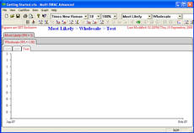
Select graph options (Graph>Edit Graph)
- Select Income
- Select Expected Colour Visible
- Move mouse over appropriate colour palette and select colour

The following screen illustrates the graph:
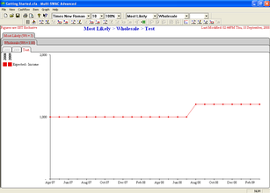
Select graph options
- Select Actual Colour Visible
- Select a different colour
- Only have months April to June for Actual
- Only have months July to March for Expected

The following screen illustrates the altered graph:
